The Virginia Smoke Free Association fights for the rights of Virginia residents wishing to reduce the harm to themselves and their loved ones from tobacco usage through the use of personal vaporizers (electronic cigarettes).  Our Mission  VSFA is an advocacy organization focused on Tobacco Harm Reduction (THR) through the use of electronic cigarettes. VSFA Represents the interest of Virginia consumers, retailers, manufacturers and support groups. We bridge the gap between Virginia and the Federal Level. Our website provides easy access to news articles, alerts, scientific research studies, pending legislation and educational materials regarding e-cigs. |  | Industry Membership  To become an Industry Member please contact us at info@virginiasmokefree.org or call (804) 318-9183.  Consumer Membership  To become a consumer member please go to www.virginiasmokefree.org and go to the membership section. There will be instructions there on how you can become a member.  Virginia Registered Lobbyist  Stephen E. Baril  Kaplan Voekler Cunningham & Frank  1401 E. Cary Street | Richmond, VA | 23219  Direct Dial | 804.823.4003 | Fax | 804.823.4099  sbaril@kv-legal.com |  |  | Virginia Smoke Free Association  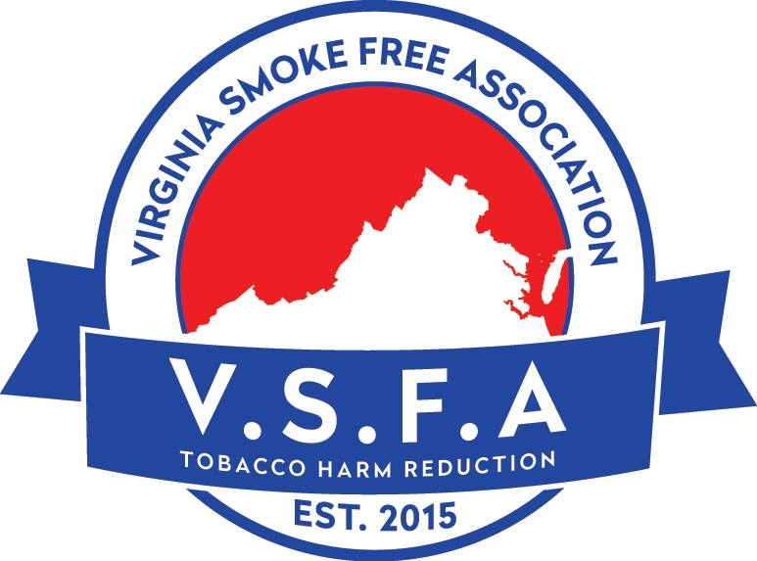  www.virginiasmokefree.org

www.virginiasmokefree.org  About Us  The Virginia Smoke Free Association is an advocacy group and trade organization focused on Tobacco Harm Reduction (THR) through the use of personal vaporizers, known as electronic cigarettes. VSFA was formed in 2015 to provide advocacy, education and support solely for the electronic cigarette industry in Virginia.  VSFA is a non-profit advocacy group organized in the Commonwealth of Virginia comprised of retail vendors, manufacturers, consumers and other supporters.  What is Tobacco Harm Reduction?  Tobacco Harm Reduction (THR) describes actions taken to lower health risks associated with using traditional tobacco products.THR is not only educating consumers about the risk of different sources of nicotine, but promoting less risky alternatives, such as electronic cigarettes. | What are Electronic Cigarettes?  Electronic cigarettes (also known as e-cigarettes or personal vaporizers) are an alternative to tobacco cigarettes. They are battery-operated devices that create a mist or vapor that is inhaled instead of smoke. The rechargeable battery powers a heating element called an “atomizer.” The element uses low heat to turn liquid in the cartridge, which contains propylene glycol, vegetable glycerin, food flavoring and nicotine, into a fog-like mist. There are many models of e-cigarettes available. Some look like traditional cigarettes, others look similar to a pen and some even look like small flashlights. They come in all shapes and sizes and have different features for former smokers who wish to distance themselves from anything resembling a traditional cigarette or want a longer battery life and/or better performance. |  | Are they a Safer Alternative?  “Nothing is ever 100% safe, so that is not the right question to ask. There is compelling evidence that they are low risk, perhaps as low as 99% less harmful than smoking. Because nothing is burned, e-cigarettes do not produce the chemicals that cause almost all the harm from smoking. E-cigarettes do not produce the particles (“tar”) that damage the lungs and heart, or carbon monoxide and the thousands of other chemicals that are created by combustion. Nicotine itself is no more dangerous to use than caffeine. It does not cause lung disease or cancer; it may temporarily raise your blood pressure a bit. E-cigarettes have been used long enough that we know they do not cause the acute health effects like lung problems and loss of stamina that smoking does and reports of adverse health effects are rare and consistently minor.” www.casaa.org  Contact Us  Virginia Smoke Free Association  10104 Chester Road  Chester, Virginia 23831  804-318-3183  info@virginiasmokefree.org
 |  |  | www.virginiasmokefree.org

